

## A MINI PROJECT REPORT

*ON*

## FITNESS TRACKER WEBSITE

*Submitted in partial fulfillment of the requirement for the award of the degree of*

## BACHELOR OF TECHNOLOGY

*IN*

## COMPUTER SCIENCE AND ENGINEERING

*BY*

**G Harsha Vardhan 19P61A0566**

**G Harsha Vardhan Rao 19P61A0575**

**S Harshith 19P61A0581**

*Under the esteemed guidance of*

***Mr. G. Anil kumar***

***Associate Professor Dept. of CSE***

**December - 2022**



(A UGC Autonomous Institution, Approved by AICTE, Affiliated to

JNTUH, Accredited by NBA & NAAC)

### DEPARTMENT OF COMPUTER SCIENCE & ENGINEERING

## **CERTIFICATE**

This is to certify that the mini project titled **“FITNESS TRACKER WEBSITE “**submitted by **G Harsha Vardhan (19P61A0566), G Harsha Vardhan rao (19P61A0575), S Harshith (19P61A0581)** in B.tech IV-I semester *Computer Science & Engineering* is a record of the bonafide work carried out by them

The results embodied in this report have not been submitted to any other University for the award of any degree

**INTERNAL GUIDE HEAD OF THE DEPARTMENT**

### Mr. G. Anil Kumar **Dr. G. Sreeram**

**(Associate professor)**

**EXTERNAL EXAMINER**

## DECLARATION

We, **G Harsha vardhan, G Harsha vardhan rao**, **S Harshith** bearing hall ticket numbers **(19P61A0566, 19P61A0575, 19P61A0581)** hereby declare that the mini project report entitled “**FITNESS TRACKER WEBSITE**” under the guidance of **Mr. G. Anil kumar,** Associate Professor, Department of Computer Science and Engineering**, Vignana Bharathi Institute of Technology, Hyderabad**, have submitted to Jawaharlal Nehru Technological University Hyderabad, Kukatpally, in partial fulfilment of the requirements for the award of the degree of Bachelor of Technology in Computer Science And Engineering.

This is a record of bonafide work carried out by us and the results embodied in this project have not been reproduced or copied from any source. The results embodied in this project report have not been submitted to any other university or institute for the award of any other degree or diploma.

**G HARSHA VARDHAN (19P61A0566) G HARSHA VARDHAN RAO(19P61A0575)**

**S HARSHITH (19P61A0581)**

## ACKNOWLEDGEMENT

We are extremely thankful to our beloved Chairman **Dr. N. Goutham Rao** who took keen interest to provide us the infrastructural facilities for carrying out the project work.

Self-confidence, hard work, commitment and planning are essential to carry out any task. Possessing these qualities is sheer waste, if an opportunity does not exist. So, we whole- heartedly thank **Dr. P. V. S. Srinivas, Principal**, and **Dr. G. Sreeram**, Head of the Department, Computer Science and Engineering for their encouragement and support and guidance in carrying out the project.

We would like to express our indebtedness to the project coordinator, **Dr. K. Kalaivani**, Associate Professor, Department of CSE, **Mr. G. Srikanth Reddy**, Associate Professor, Department of CSE, **Mr. G. Anil kumar** , Associate Professor, Department of CSE, for her valuable guidance during the course of project work.

We thank our Project Guide, **Mr. G. Anil kumar ,** Associate Professor, for providing us with an excellent project and guiding us in completing our mini project successfully.

We would like to express our sincere thanks to all the staff of Computer Science and Engineering, VBIT, for their kind cooperation and timely help during the course of our project. Finally, we would like to thank our parents and friends who have always stood by us whenever we were in need of them.

## ABSTRACT

The project is a responsive website designed/developed using HTML, CSS, JAVASCRIPT and BOOTSTRAP. FITNESS TRACKER WEBSITE is a website that looks around the nutrition and wellness of the users. Users can visit the website and check for the calorific science and much more nutritional information. Fitness is the emerging trend throughout the world. Getting into a good physique has become a motive for most of the youth and also different age groups. Because of the increased stress and indulging into unhealthy food habits, people are suffering from obesity and various diseases at very younger ages.

Regular physical activity helps avoid weight gain and plays a part in increasing wellbeing by reducing stress, anxiety, and feelings of depression. People are unaware of the calorific and nutritional sciences. People now-a-days are very much interested in getting into a good physique as it makes the person look good as well as makes him confident as per some studies. So, Our Main Aim is to help out everyone reaching out to our website for any possible information.

## CONTENTS

### CHAPTER PAGE NO.

#### LIST OF FIGURES

1. **Introduction**
   1. Introduction to the system 1
   2. Problem Definition 1
   3. Objectives 2
   4. Aim of the project 2
2. Literature Survey
   1. Existing System 5
   2. Proposed System 5
   3. Scope of the project 6
3. Analysis
   1. Technical Feasibility 8
   2. Operational Feasibility 8
   3. Economical Feasibility 9
4. Hardware and Software requirements
   1. Software requirements 11
   2. Hardware requirements 11
5. System Design

UML Diagrams 13-22

#### Results and Performance Evaluation 24-32

1. **Conclusion and Future Work** 34
2. **References** 35

**List of Figures**

|  |  |  |
| --- | --- | --- |
| **S.NO.** | **Figure Name** | **Page No.** |
| 1. | Use case Diagram | 17 |
| 2. | Class Diagram | 19 |
| 3. | Activity Diagram | 21 |
| 4. | Sequence Diagram | 22 |
| 5. | BMI Calculator | 30 |
| 6. | Calorie Calculator | 31 |
| 7. | Macros Calculator | 31 |
| 8. | Food Chart | 32 |

# CHAPTER – 1

## INTRODUCTION

### INTRODUCTION TO THE SYSTEM

The development and the incorporation of wireless technologies to promote healthy lifestyle behavior, specifically healthy eating and weight control, has the potential to address our ultimate goal of enabling healthy lifestyle to prevent obesity and obesity related diseases.

A diet is all that we consume in a day. And a balanced diet is a diet that contains an adequate quantity of the nutrients that we require in a day. A balanced diet includes six main nutrients, i.e. Fats, Protein, Carbohydrates, Fiber, Vitamins, and Minerals.All these nutrients are present in the foods that we eat. Different food items have different proportions of nutrients present in them. The requirements of the nutrients depend on the age, gender, and health of a person.

#### “Your diet is a bank account.

**Good food choices are good investments.”**

As mentioned above the diet is important part of our life and this diet app allows the user to meet their goal easily. The diet plan recommend eating wide variety of food including vegetables, whole grains, fruits, non-fat, low-fat, dairy products, beans, lean meat, poultry, and fish.

However, each person has a unique dietary pattern and different health issues so system creates a meal plan depending on each case. The project is aimed in such a way that the user need not to go to dietician centre to get their diet plan, they can easily access the diet plan through app.

### PROBLEM STATEMENT

People are becoming more and more health-conscious, but they don’t find enough time to go to a gym dedicatedly. This is why health apps and fitness tracking apps are preferred by working people all around the world. There is a lot of content available on the internet about everything. Sadly, as the internet is available everywhere and to everyone, it is subjected to have incorrect information as well.

The same goes for health and fitness information available on the internet. It has become difficult to differentiate between the facts and myths. People were not aware of what is right and what is wrong.

The nutrition guide includes a meal plan for weight loss and gain. In fact, users may also make a food journal with this health fitness app. Our developed fitness and healthcare app provides factual information and saves the precious time of users.

### OBJECTIVE

There is a need to study and make a system which will make it easy for an end users to go through the fitness app contents and know more about calorific science and be healthy.

* To make app available to the user any time
* To provide clear and easy to understand information
* To allow the user to download the diet plan
* To make the app user friendly

### AIM OF THE PROJECT

Our Main Aim is to help out everyone reaching out to our website for any possible information such a way that the user need not to go to dietician centre to get their diet plan, they can easily access the diet plan through website.

# CHAPTER - 2

## LITERATURE SURVEY

Nutrition plays a vital role in a person’s overall health. The importance of a good and healthy diet has been recorded as far back as Hippocrates (Greece, ca460BC - ca370BC) who said “Let food be thy medicine and thy medicine be thy food” (Nordqvist, 2013).

Today, with changing lifestyle habits and exposure to fast food and processed meals, one is compelled to question the effect that diet and nutrition have on diseases, illness, longevity, brain function, cognition, learning and social behaviour to name only a few.

Brigham Young University states that "nutritional Science investigates the metabolic and physiological responses of the body to food and diet, including the role of nutrients in the cause, treatment, and prevention of disease" (Nordqvist, 2013). Medical science is constantly moving forward with new findings and ideas, and the internet provides a valuable source of literature.

The most threatening health issues in the world today are associated with the problem of weight.Traditionally, weight related issues have been handled through counseling and emphasis on a proper diet and exercise, but nothing had been done in the making of such things accessible. The campaigns are centered on talks about nutritional practices and the consequences of the lack of such habits thereof. The individuals have been left to battle with their issues through establishing their disciplined healthy regimes.

### EXISTING SYSTEM

Smartphones and apps have revolutionized fitness training. The days when average consumers only got a training plan in the gym are long gone. Nine percent of all apps on offer are now fitness apps. And they're more popular than ever. The companies initially tried to make a profit with training equipment that matched their app.

### PROPOSED SYSTEM

The proposed system of Fitness And healthcare website is that it calculates the BMI of users based on their input height and weight. It also calculates no of grams of calories micro and macro nutrients a person should take according to their age height and weight. It also enables a user to know about the food intake in foodchart.

* + - Website is the most powerful weapon for communication.
    - The main reason we created this website is for communication.
    - For the first time we decided to build/design a website we started making it from scratch using HTML, CSS and a bit of JavaScript.
    - Our website has a calorie counter and daily calorie profile .
    - We will also add recipes and macro , micro nutrient profile .

The proposed Dietitian System measures a user’s body mass index based on his/her height and weight. The user has to then enter his eating timings and the system presents him/her the diet plan that would be best for that particular user. All the food items along with the quantity is shown to the user. If the user doesn’t like the current diet plan, the system modifies food items keeping the total nutritional value same

In this app the first page is of login the client login into the system. The client can fill data like Name, Age, Gender, Email-Id, Password, and so forth. From utilizing Email- Id and Password he can login to system. After effectively login client visits to BMI count structure, client needs to enter individual data like age, tallness, weight. By, weight the BMI and BMR is acquired. On the premise of BMI result diet plan will be given. By the most widely recognized individuals with a BMI under 18.5 are considered too thin, BMI more than 25 are overweight, BMI in the middle of 18.5 and 25 are have sound weight and those with a BMI more than 30 are viewed as corpulent .

In the event that client's BMI is under 18.5 then he got recommendation about weight pick up and on the off chance that it is more than 25 he got weight reduction proposal generally client got sound proposals.

### SCOPE OF THE PROJECT

Scope is based on the goals of your website and needs of your users. Specifically: how will you meet the goals of your website and satisfy the needs of your users? Let's define the scope of your website project by breaking it into two parts: functionality and content.

Functionality: What features do you want on your website, and how will they function? This may include a form to collect contact information or database built to offer complex quotes. Be sure to include: data requirements and usability requirements.

* An app is a user friendly
* Provide information about weight loss, weight gain, weight maintain etc Provide Searching and reading diet plan.
* Provide reading daily health tips.

# CHAPTER - 3

## ANALYSIS

The major step in analysis is to verify the feasibility of the proposed system. “All projects are feasible given unlimited resources and infinite time“. But in reality, both resources and time are scarce. Project should confirm to be time effective and should be optimal in their consumption of resources. This plays a constant role in approval of any project.

Three key considerations involved in the feasibility analysis are

* + Technical Feasibility
  + Operational Feasibility
  + Economical Feasibility

## Technical Feasibility

To determine whether the proposed system is technically feasible, we should take into consideration the technical issues involved behind the system. Android project uses the android-based technologies, which is rampantly employed these days worldwide. The world without the internet is incomprehensible today. That goes to render that the proposed system is technically feasible.

## Operational Feasibility

To determine the operational feasibility of the system we should take into consideration the awareness level of the users. This system is operationally feasible since the users are familiar with the android technologies and hence there is no need to gear up or train the personnel to use the cell phones. Also, the system (android phones) is very friendly and easy to use.

## Economical Feasibility

as

To decide whether a project is economically feasible, we have to consider various factors as:

* Cost benefit analysis
* Long-term returns
* Maintenance costs

The proposed system is android based. It requires average computing capabilities and access to the internet, which are very basic requirements hence it doesn’t incur any **additional economic overheads, which renders the system to be economically feasible.**

# CHAPTER - 4

## 4. HARDWARE AND SOFTWARE REQUIREMENTS

### Hardware Requirements

* **Processor:** Intel i5
* **RAM:** 4GB
* **Android Device/Mobile/Desktop**

### Software Requirements

* + - **Operating System:** WINDOWS 10
    - **Front End:** HTML, CSS, JAVASCRIPT and BOOTSTRAP
    - **Browser:** Google Chrome, Internet Explorer 8.0 and above, Mozilla Firefox etc

11

# CHAPTER - 5

## 5 . SYSTEM DESIGN

System design is the transition from a user-oriented document to programmers or database personnel. The design is a solution, specifying how to approach to the creation of a new system. This is composed of several steps. It provides the understanding and procedural details necessary for implementing the system recommended in the feasibility study. Designing goes through logical and physical stages of development. Logical design reviews the present physical system, prepare input and output specification, details of implementation plan and prepare a logical design walkthrough.

The database tables are designed by analysing functions involved in the system and format of the fields is also designed. The fields in the database tables should define their role in the system. The unnecessary fields should be avoided because it affects the storage areas of the system. Then, in the input and output screen design, the design should be made user friendly. The menu should be precise and compact.

## SOFTWARE DESIGN

In designing the software, the following principles are followed:

* + Modularity and partitioning: software is designed in such a way that each system should consist of hierarchy of modules and serve to partition into separate function.
  + Coupling: modules should have little dependency on the other modules of a system.
  + Cohesion: modules should carry out the operations in a single processing function.
  + Shared use: avoid duplication by allowing a single module which is called by other, that needs the function it provides.

## INPUT DESIGN

Considering the requirements, procedures are adopted to collect the necessary input data in most efficiently designed format. The input design has to be done keeping in view that, the interaction of the user with the system should be in the most effective and simplified way. Also, the necessary measures are taken for the following

* + Controlling the amount of input
  + Avoid unauthorized access to the users
  + Eliminating the extra steps
  + Keeping the process simple
  + At this stage the input forms and screens are designed.

## OUTPUT DESIGN

All the screens of the system are designed with a view to provide the user with easy operations in a simpler and efficient way, with minimum key strokes possible. Important information is emphasized on the screen. Almost every screen is provided with no error and important messages and option selection facilitates. Emphasis is given for faster processing and speedy transactions between the screens. Each screen assigned to make it as much user friendly as possible by using interactive procedures. In other words, we can say that the user can operate the system without much help from the operating manual.

## UML DIAGRAMS

**Unified Modelling Language**

UML is an acronym that stands for **Unified Modeling Language**. Simply put, UML is a modern approach to modeling and documenting software. In fact, it’s one of the most popular business process modeling techniques. It is based on **diagrammatic representations** of software components. As the old proverb says: “a picture is worth a thousand words”. By using visual representations, we are able to better understand possible flaws or errors in software or business processes.

The elements are like components which can be associated in different ways to make a complete UML picture, which is known as diagram. Thus, it is very important to understand the different diagrams to implement the knowledge in real-life systems.

Any complex system is best understood by making some kind of diagrams or pictures. These diagrams have a better impact on our understanding. If we look around, we will realize that the diagrams are not a new concept but it is used widely in different forms in different industries.

We prepare UML diagrams to understand the system in a better and simple way. A single diagram is not enough to cover all the aspects of the system. UML defines various kinds of diagrams to cover most of the aspects of a system.

You can also create your own set of diagrams to meet your requirements. Diagrams are generally made in an incremental and iterative way.

### Contents:

* + Use case Diagram
  + Class Diagram
  + Activity Diagram
  + Sequence Diagram

### USE CASE DIAGRAM

A use case diagram contains four components:

* + - The boundary, which defines the system of interest in relation to the world around it.
    - The actors, usually individuals involved with the system defined according to their roles.
    - The use cases, which are the specific roles played by the actors within and around the system.
    - The relationships between and among the actors and the use cases.

The actors can be human user, some internal applications or may be some external applications. So in a brief when we are planning to draw a use case diagram we should have the following items identified.

1. Functionalities to be represented as an use case
2. Actors
3. Relationships among the use cases and actors.

Use case diagrams are drawn to capture the functional requirements of a system. So after identifying the above items we have to follow the following guidelines to draw an efficient use case diagram.

1. The name of the use case is very important. So the name should be chosen in such a way so that it can identify the functionalities performed.
2. Give a suitable name for actors.
3. Show relationship and dependencies clearly in the diagram.
4. Do not try to include all types of relationships. Because the main purpose of the diagram is to identify requirements.
5. Use note whenever required to clarify some important points.

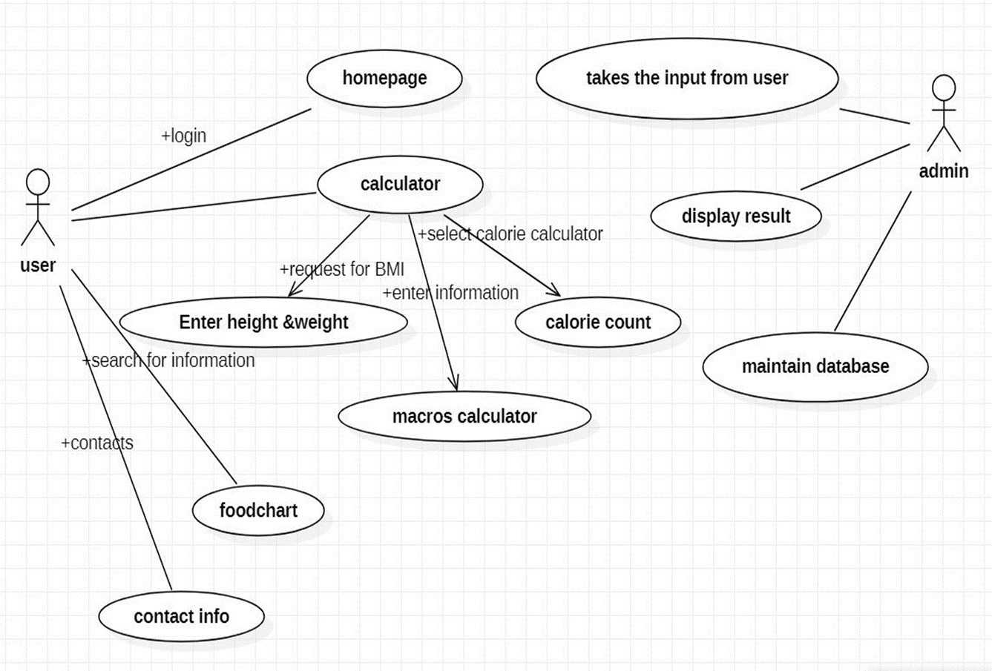

**Fig:5.1** Use case Diagram for Fitness Tracker

### CLASS DIAGRAM

The purpose of the class diagram is to model the static view of an application. The class diagrams are the only diagrams which can be directly mapped with object oriented languages and thus widely used at the time of construction.

Class diagrams have lot of properties to consider while drawing but here the diagram will be considered from a top level view.

Class diagram is basically a graphical representation of the static view of the system and represents different aspects of the application. So a collection of class diagrams represent the whole system.

The following point should be remembered while drawing a class diagram:

* 1. The name of the class diagram should be meaningful to describe the aspect of the system.
  2. Each element and their relationships should be identified.
  3. Attributes and methods of each class should be clearly identified.

For each class minimum number of properties should be specified. Because unnecessary properties will make the diagram complicated

#### PURPOSE OF CLASS DIAGRAMS

* + - Analysis and design of the static view of an application.
    - Describe responsibilities of a system.
    - Base for component and deployment diagrams.
    - Forward and reverse engineering

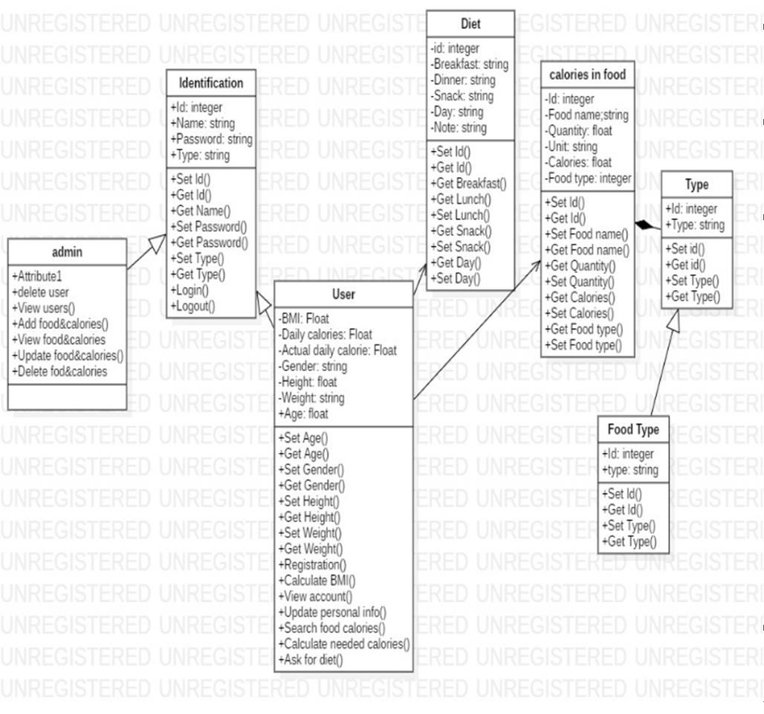

**Fig:5.2** Class Diagram for Fitness Tracker

### ACTIVITY DIAGRAM

* + - It shows the flow of the various activities that are undergone from the beginning till the end.
    - It consists of the activities that are held and carried out throughout the session from starting till the ending stage.

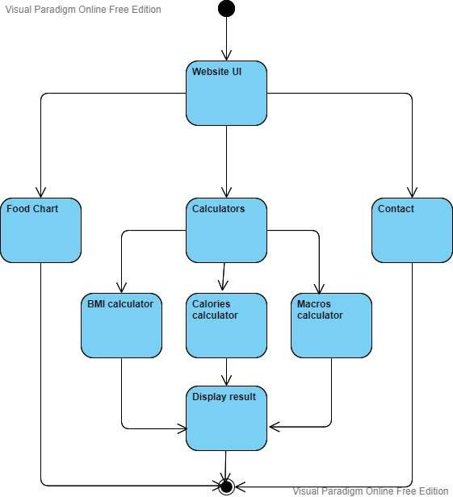

**Fig:5.3** Activity Diagram for Fitness Tracker

### SEQUENCE DIAGRAM

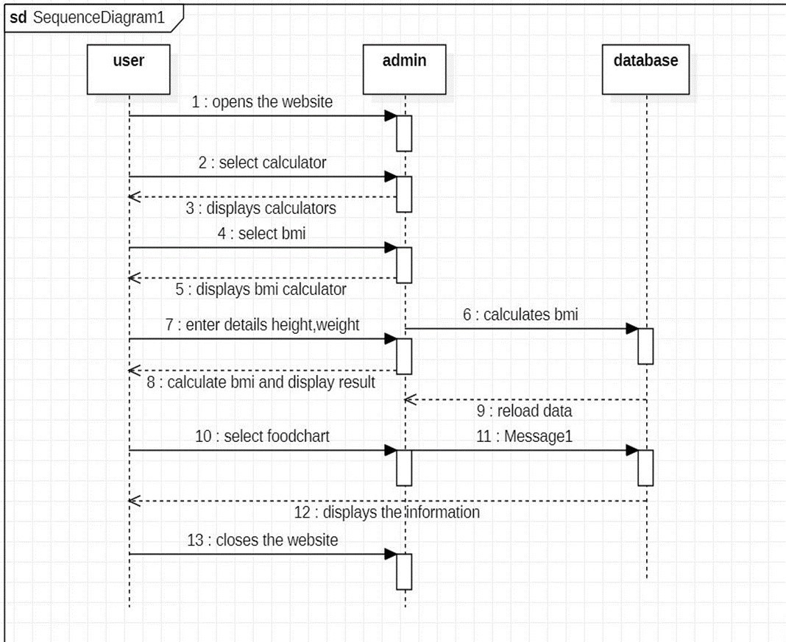

**Fig:5.4** Sequence Diagram for Fitness Tracker

* + - It shows the sequence of the steps that are carried out throughout the process of execution.
    - It involves lifelines or life time of a process that shows the duration for which the process is alive while the steps are taking place in the sequential manner.
    - Sequence diagram specifies the order in which the various steps are executed.

# CHAPTER - 6

### PERFORMANCE EVALUATION AND RESULTS

### Modules

#### Home

This is the home module, this is where you enter the website for the first time.in this module, you can find different modules like Calculators, Food Charts, and Contact Us modules and a search bar

#### Food chart

This is the second module of the website .in this module you can find the nutritional values of daily foods according to their quantities in grams apart from that this module also shows the high protein, carbohydrates, and protein-containing foods for the people who need some help in maintaining a healthy diet.

#### Calculators

This is the third module of the website where it has got three calculators they are :

#### BMI calculator

This calculator is used to calculate the body mass index of a person based on the height and weight of that person.

#### Macros calculator

This is another calculator in the drop-down menu in the Calculators module .this calculator calculates the amount of fat, proteins, and carbohydrates that we should consume by taking the height and weight as inputs

#### Calorie calculator

This is the final calculator in the drop-down list.in this calculator, we calculate the base metabolic rate of a male or a female using the formula Your basal metabolism rate is produced through the following basal metabolic rate formula: Men: BMR = 88.362 + (13.397 x weight in kg) + (4.799 x height in cm)

24

– (5.677 x age in years) Women: BMR = 447.593 + (9.247 x weight in kg) + (3.098 x height in cm) – (4.330 x age in years)

#### Contact us

Here we provide the address of the office, and other social media platform addresses, and here we include a chat feature that directly connects us with our fitness personnel who can guide you.

### CODING

**index.html**

<!doctype html>

<html lang="en">

<head>

<meta charset="utf-8">

<meta name="viewport" content="width=device-width, initial- scale=1"> <link rel="stylesheet" href="style.css">

<link href="[https://cdn.jsdelivr.net/npm/bootstrap@5.0.0-](https://cdn.jsdelivr.net/npm/bootstrap%405.0.0-) beta1/dist/css/bootstrap.min.css" rel="stylesheet" integrity="sha384- giJF6kkoqNQ00vy+HMDP7azOuL0xtbfIcaT9wjKHr8RbDVddVHyTfAAsrekwKmP1" crossorigin="anonymous">

<title>FITNESS HEALTH CARE</title>

</head>

<body>

<!-- navbar -->

<nav class="navbar navbar-expand-lg navbar-dark bg- dark"> <div class="container-fluid">

<a class="navbar-brand" href="#"><h1 style="color: red;">FITNESS HEALTH CARE</h1></a>

<button class="navbar-toggler" type="button" data-bs-toggle="collapse" data- bs- target="#navbarSupportedContent" aria-controls="navbarSupportedContent" aria- expanded="false" aria-label="Toggle navigation">

<span class="navbar-toggler-icon"></span>

25

</button>

<div class="collapse navbar-collapse" id="navbarSupportedContent">

<ul class="navbar-nav me-auto mb-2 mb-lg-0">

<li class="nav-item">

<a class="nav-link active" aria-current="page" href="#">Home</a>

</li>

<li class="nav-item">

<a class="nav-link" aria-current="page" href="./foodchart.html">Food Chart</a>

</li>

<li class="nav-item dropdown">

<a class="nav-link dropdown-toggle" href="#" id="navbarDropdown" role="button" data-bs-toggle="dropdown" aria-expanded="false"> CALCULATORS

</a>

..................Column Break..................

<ul class="dropdown-menu" aria-labelledby="navbarDropdown">

<li><a class="dropdown-item" href="bmi.html">BMI

CALCULATOR</a></li>

<li><a class="dropdown-item" href="calorie.html">CALORIE CALCULATOR</a></li>

<li><a class="dropdown-item" href="protein.html">MACROS CALCULATOR</a></li>

</ul>

</li>

<li class="nav-item">

<a class="nav-link" aria-current="page" href="./contact.html">Contact Us</a> </li>

</ul>

<form class="d-flex">

<input class="form-control me-2" type="search" placeholder="Search" aria- label="Search">

<button class="btn btn-outline-success" type="submit">Search</button> </form>

</div>

</div>

26

</nav>

<div class="main body">

<div class="m-4" style="color: rgb(237, 175, 17);"> <ul>

<li>

<h5>

Success usually comes to those who are too busy to be looking for it!

</h5>

</li>

<li>

<h5>

All progress takes place outside the comfort zone!

</h5>

</li>

<li>

<h5>

All our dreams can come true if we have the courage to pursue them!

</h5>

</li>

</ul>

</div>

</div>

<div style="color: white;" class="container">

<div class="row g-0">

<div class="col-sm-6 col-md-8">

<h1 class="statement">BEING HEALTHY ISN'T A FAD OR A TREND. IT'S A LIFESTYLE. </h1>

</div>

<div class="col-6 col-md-4"></div>

</div>

</div>

<script src="[ttps://cdn.jsdelivr.net/npm/bootstrap@5.0.0-](mailto:cdn.jsdelivr.net/npm/bootstrap@5.0.0-) beta1/dist/js/bootstrap.bundle.min.js" integrity="sha384- ygbV9kiqUc6oa4msXn9868pTtWMgiQaeYH7/t7LECLbyPA2x65Kgf80OJFdroafW" crossorigin="anonymous"></script

<script src="//code.tidio.co/lhkzvq5umzfab1cuutdopgmhfsi2nabj.js" async></script>

</body>

</html>

27

### bmi.html

<!doctype html>

<html lang="en">

<head>

<!-- Required meta tags -->

<meta charset="utf-8">

<meta name="viewport" content="width=device-width, initial- scale=1"> <link rel="stylesheet" href="style.css"> <script src="./javascript.js"></script>

<link href="[https://cdn.jsdelivr.net/npm/bootstrap@5.0.0-](https://cdn.jsdelivr.net/npm/bootstrap%405.0.0-) beta1/dist/css/bootstrap.min.css" rel="stylesheet" integrity="sha384- giJF6kkoqNQ00vy+HMDP7azOuL0xtbfIcaT9wjKHr8RbDVddVHyTfAAsrekwKmP1" crossorigin="anonymous">

<title> FITNESS HEALTH CARE</title>

</head>

<body>

<!-- navbar -->

<nav class="navbar navbar-expand-lg navbar-dark bg-dark">

<div class="container-fluid">

<a class="navbar-brand" href="#"><h1 style="color: red;">FITNESS HEALTH CARE </h1></a>

<button class="navbar-toggler" type="button" data-bs-toggle="collapse" data- bs- target="#navbarSupportedContent" aria-controls="navbarSupportedContent" aria- expanded="false" aria-label="Toggle navigation">

<span class="navbar-toggler-icon"></span>

</button>

<div class="collapse navbar-collapse" id="navbarSupportedContent">

<ul class="navbar-nav me-auto mb-2 mb-lg-0">

<li class="nav-item">

<a class="nav-link" aria-current="page" href="index.html">Home</a>

</li>

<li class="nav-item">

<a class="nav-link" aria-current="page" href="./foodchart.html">Food Chart</a>

</li>

<li class="nav-item dropdown">

<a class="nav-link dropdown-toggle active" href="#" id="navbarDropdown" role="button" data-bs-toggle="dropdown" aria-expanded="false"> CALCULATORS

</a>

<ul class="dropdown-menu" aria-labelledby="navbarDropdown">

<li><a class="dropdown-item" href="bmi.html">BMI

CALCULATOR</a></li>

<li><a class="dropdown-item" href="calorie.html">CALORIE CALCULATOR</a></li>

<li><a class="dropdown-item" href="protein.html">MACROS CALCULATOR</a></li>

</ul>

28

</li>

<li class="nav-item">

<a class="nav-link" aria-current="page" href="./contact.html">Contact Us</a> </li>

</ul>

<form class="d-flex">

<input class="form-control me-2" type="search" placeholder="Search" aria- label="Search">

<button class="btn btn-outline-success" type="submit">Search</button> </form>

</div>

</div>

</nav>

<div class="mainbody ">

<div>

<div class="changemargin" style="color: rgb(255, 187, 0);">

<p id="intro"><h5>Calculate your BMI (body mass index) by using the form below. Enter your weight and height and click the Calculate button to display your BMI result.</h5></p>

</div>

<form action="none" method="post" name="bmiform"> <fieldset>

<h5><span class="badge bg-danger">Height and Weight</span></h5> <div>

<label for="inches">Height (cms):</label>

<input type="text" name="inches" id="inches">

</div>

<br>

<div>

<label for="pounds">Weight (kgs):</label>

<input type="text" name="pounds" id="pounds"></div> <br>

<button type="button" class="changemargin btn btn-info" name="calculate" value="Calculate your BMI" onclick="calcBMI()">Calculate your BMI</button>

</fieldset>

<fieldset>

<h5 class="changemargin"><span class="badge bg-danger">BMI</span></h5>

<label for="bmi" id="bmi_label">Your calculated BMI is:</label> <input type="text" name="bmi" id="bmi" readonly="readonly">

<h5 class="changemargin" id="healthybmi" style="visibility: hidden;"><span class="badge bg-success">Healthy BMI</span></h5>

<h5 class="changemargin" id="underweightbmi" style="visibility: hidden;"><span class="badge bg- warning">UNDERWEIGHT</span></h5>

<h5 class="changemargin" id="overweightbmi" style="visibility: hidden;"><span class="badge bg- danger">OVERWEIGHT</span></h5>

29

</fieldset>

</form>

</div>

</div>

<script src="[https://cdn.jsdelivr.net/npm/bootstrap@5.0.0-](https://cdn.jsdelivr.net/npm/bootstrap%405.0.0-) beta1/dist/js/bootstrap.bundle.min.js" integrity="sha384- ygbV9kiqUc6oa4msXn9868pTtWMgiQaeYH7/t7LECLbyPA2x65Kgf80OJFdroafW" crossorigin="anonymous"></script>

<script src="//code.tidio.co/lhkzvq5umzfab1cuutdopgmhfsi2nabj.js" async></script>

</body>

</html>

**BMI CALCULATION:**

BMI =(weight/(height*height))/10,000

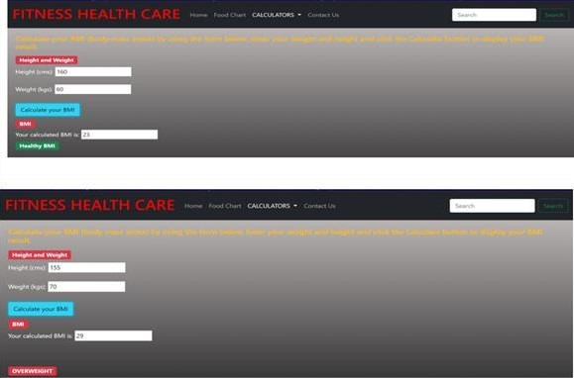

Fig:6.1 : BMI calculator for Fitness Tracker

## CALORIES CALCULATION:

For Male:

Required calories per day are: 66.47 + (13.75 * weight) + (5.0 * height - (6.75 * age))

For Female:

Required calories per day are: 665.09 + (9.56 * weight) + (1.84 * height - (4.67 * age))

30

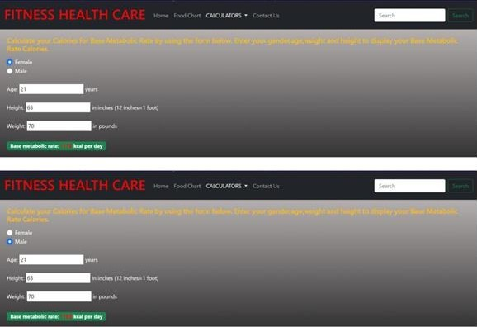

Fig 6.2 : Calorie Calculator for Fitness Tracker

**PROTEINS CALCULATION:**

**Proteins required are**: weight*0.8 **Fats required are:** weight/2 **Carbohydrates required are:** weight*2

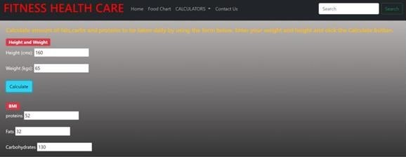

Fig 6.3: Macros calculator for Fitness Tracker

31

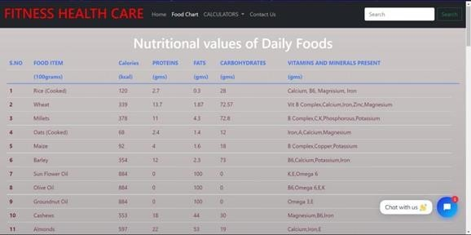

Fig 6.4: Food Chart for Fitness Tracker

32

# CHAPTER - 7

## 7. CONCLUSION AND FUTURE WORK

* + - * Being fit has an infinite benefits to your health. It will help you live longer ,it will keep your body strong and gives a good impression of your sense of self worth to those around you. It will show them that you truly care about yourself .It will keep your cardiovascular system functioning without fault even at old age.
      * As being fit is very much important , we developed a website on fitness healthcare where one can check their BMI, amount of proteins, calories ,fats and carbohydrates they should consume per day and follow their diet plan accordingly .We have also provided a food chart that has amount of calories ,proteins, carbohydrates contained in different food items. So, one can refer to that food chart and follow the diet plan.
      * In addition to the current website, we can add a database, where we can collect the informationof our users individually, and whenever they enter the website the data will be pre-available tothe medic just need to analyze it and give us a report. Apart from that, we can incorporate machine learning to predict some diseases and health problems that usually occur at a certain age and if fulfill certain conditions we can come to the conclusion that he is most likely to havea health disorder so, he can refer to doctor. We can also add an online doctor consultation facility where the users just need to book an appointment on the website and pay the fees onlineafter the consultation this can save a lot of time, effort, and money for the user.

34

## 8 . REFERENCES

* Refsnes Data, W3schools (HTML, CSS, JAVASCRIPT)
* **Mark Otto** and **Jacob Thornton, Aug 2017,** Bootstrap 4 Documentation (Bootstrap)
* **Mosh** Hamedani,2020, Codewithmosh (NodeJS)
* Eat smart, Move more, Sleep right by Luke Coutinho

35